Blinkit Grocery Data SQL Queries
SELECT COUNT(*) from Blinkit_Data
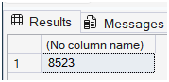
Data Cleaning:
UPDATE Blinkit_Data
SET Item_Fat_Content =
CASE
WHEN Item_Fat_Content IN ('LF', 'Low fat') THEN 'Low Fat'
WHEN Item_Fat_Content = 'reg' THEN 'Regular'
ELSE Item_Fat_Content
END
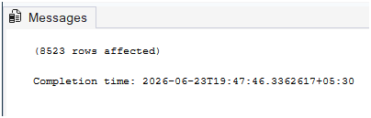
SELECT DISTINCT(Item_Fat_content) FROM Blinkit_Data
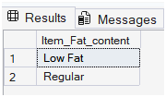
SELECT CONCAT(CAST(SUM(Total_sales)/1000000 AS decimal(10,2)),'M') Total_sales_Million
from Blinkit_Data
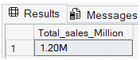
SELECT CAST(AVG(Total_Sales) AS decimal(10,2)) AS Avg_sales from Blinkit_Data
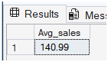
SELECT COUNT(*) AS No_of_Items FROM Blinkit_Data
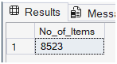

SELECT CAST(AVG(Rating) AS DECIMAL(10,2)) AS Avg_Rating from Blinkit_Data
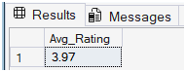
SELECT Item_Fat_Content,CAST(SUM(Total_Sales) AS DECIMAL (10,2)) Total_Sales from Blinkit_Data
GROUP BY Item_Fat_Content
ORDER BY Total_Sales DESC
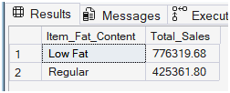
SELECT Item_Fat_Content,
CAST(SUM(Total_Sales) AS DECIMAL (10,2)) Total_Sales,
CAST(AVG(Total_Sales) AS decimal(10,2))AS Avg_sales,
COUNT(*) AS No_of_Items,
CAST(AVG(Rating) AS DECIMAL(10,2)) AS Avg_Rating

FROM Blinkit_Data
GROUP BY Item_Fat_Content
ORDER BY Total_Sales DESC
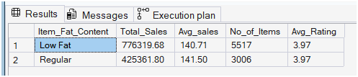
SELECT Item_Fat_Content,
CAST(SUM(Total_Sales) AS DECIMAL (10,2)) Total_Sales,
CAST(AVG(Total_Sales) AS decimal(10,2))AS Avg_sales,
COUNT(*) AS No_of_Items,
CAST(AVG(Rating) AS DECIMAL(10,2)) AS Avg_Rating

FROM Blinkit_Data
WHERE Outlet_Establishment_Year =2022
GROUP BY Item_Fat_Content
ORDER BY Total_Sales DESC
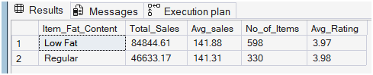
SELECT Item_Type,
CAST(SUM(Total_Sales) AS DECIMAL (10,2)) Total_Sales,
CAST(AVG(Total_Sales) AS decimal(10,2))AS Avg_sales,
COUNT(*) AS No_of_Items,
CAST(AVG(Rating) AS DECIMAL(10,2)) AS Avg_Rating

FROM Blinkit_Data
GROUP BY Item_Type
ORDER BY Total_Sales DESC
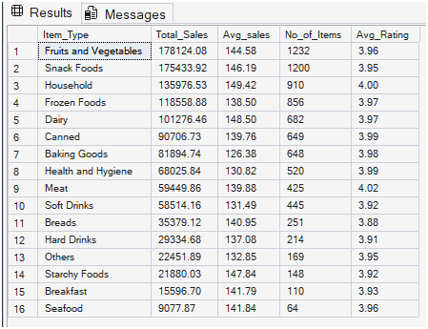
SELECT Outlet_Location_Type,
ISNULL([Low Fat], 0) AS Low_Fat,
ISNULL([Regular], 0) AS Regular
FROM
(
SELECT Outlet_Location_Type, Item_Fat_Content,
CAST(SUM(Total_Sales) AS DECIMAL(10,2)) AS Total_Sales
FROM blinkit_data
GROUP BY Outlet_Location_Type, Item_Fat_Content
) AS SourceTable
PIVOT
(
SUM(Total_Sales)
FOR Item_Fat_Content IN ([Low Fat], [Regular])
) AS PivotTable
ORDER BY Outlet_Location_Type;
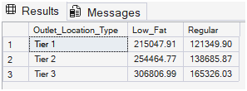
SELECT Outlet_Establishment_Year, CAST(SUM(Total_Sales) AS DECIMAL(10,2)) AS Total_Sales
FROM blinkit_data
GROUP BY Outlet_Establishment_Year
ORDER BY Outlet_Establishment_Year
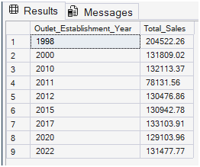
SELECT Outlet_Establishment_Year, CAST(SUM(Total_Sales) AS DECIMAL(10,2)) AS Total_Sales,
CAST(AVG(Total_Sales) AS decimal(10,2))AS Avg_sales,
COUNT(*) AS No_of_Items,
CAST(AVG(Rating) AS DECIMAL(10,2)) AS Avg_Rating
FROM blinkit_data
GROUP BY Outlet_Establishment_Year
ORDER BY Outlet_Establishment_Year
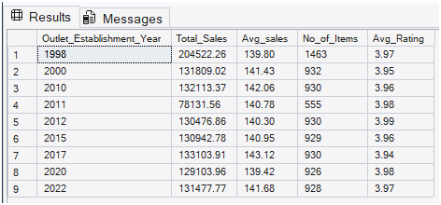
SELECT
Outlet_Size,
CAST(SUM(Total_Sales) AS DECIMAL(10,2)) AS Total_Sales,
CAST((SUM(Total_Sales) * 100.0 / SUM(SUM(Total_Sales)) OVER()) AS DECIMAL(10,2)) AS Sales_Percentage
FROM blinkit_data
GROUP BY Outlet_Size
ORDER BY Total_Sales DESC;
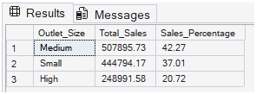

SELECT Outlet_Location_Type, CAST(SUM(Total_Sales) AS DECIMAL(10,2)) AS Total_Sales,
CAST(AVG(Total_Sales) AS decimal(10,2))AS Avg_sales,
CAST((SUM(Total_Sales) * 100.0 / SUM(SUM(Total_Sales)) OVER()) AS DECIMAL(10,2)) AS Sales_Percentage,
COUNT(*) AS No_of_Items,
CAST(AVG(Rating) AS DECIMAL(10,2)) AS Avg_Rating
FROM blinkit_data
GROUP BY Outlet_Location_Type
ORDER BY Outlet_Location_Type DESC
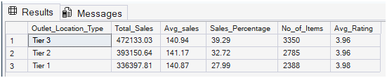
SELECT Outlet_Type, CAST(SUM(Total_Sales) AS DECIMAL(10,2)) AS Total_Sales,
CAST(AVG(Total_Sales) AS decimal(10,2))AS Avg_sales,
CAST((SUM(Total_Sales) * 100.0 / SUM(SUM(Total_Sales)) OVER()) AS DECIMAL(10,2)) AS Sales_Percentage,
COUNT(*) AS No_of_Items,
CAST(AVG(Rating) AS DECIMAL(10,2)) AS Avg_Rating
FROM blinkit_data
GROUP BY Outlet_Type
ORDER BY Sales_Percentage DESC
